Sum-Meet
Use Case Specification

Submitted to:

Asst. Prof. Ma. Rowena C. Solamo
Faculty Member
Department of Computer Science
College of Engineering
University of the Philippines, Diliman

Submitted by:
Batula, Bryce Spencer
Bayuga, Michael John
Yap, John Theodore

In partial fulfillment of academic requirements
for the course
CS 191 Software Engineering I
of the
1st Semester, AY 2015-2016
Unique Reference:
The documents are stored in https://github.com/trackertech568/CS191-Batula-Bayuga-Yap.
[File Reference in GitHub, preferably link.]

Document Purpose:
To show the flow of events of a use-case from its diagram.

Target Audience:
Meeting organizers.

Revision Control

History Revision:
Revision Date | Person Responsible | Version  Number | Modification
09/18/15 | Batula, Bryce  Bayuga, Michael  Yap, John Theodore | 1.0 | Initial Document; Version number should match the one found in the footer.

Use-Case Name: 4.0 View Schedule

Description: Both the attendee and the meeting organizer have access on this one. The system will show the schedules for them. It also shows the available dates for a new meeting.

Preconditions: NONE

Flow of Events:
Scenario Name | Description
Scenario 1 (Basic Flow)  Attendee or the meeting organizer wants to view their schedule. | 1. Either the attendee or the meeting organizer wants to access their schedule.  2. System will access the built in calendar for the schedules.

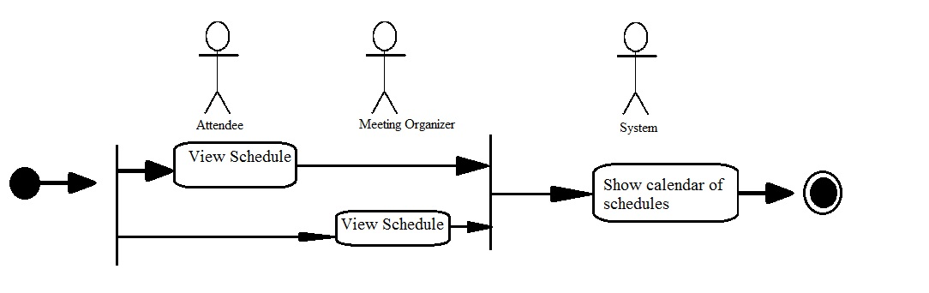

Activity Diagram of the Flow of Events:

Postcondition: NONE

Relationships: NONE

Special Requirements: NONE

